Research Management System

A Project Report Submitted

to

MANIPAL ACADEMY OF HIGHER EDUCATION

For Partial Fulfillment of the Requirement for the

Award of the Degree

Of

Bachelor of Technology

in

Information Technology

by

Satyam Bhattacharjee, Shivam Singh, Siddhartha Chhauda, Kartik Rao

220911586, 220911596, 220911602, 220911588

Under the guidance of

Dr. Ritesh Sharma (Lab Faculty 1) Dr. Raghavendra S.(Lab faculty 2)

Assistant Professor Associate Professor

Department of I&CT Department of I&CT

Manipal Institute of Technology Manipal Institute of Technology

****Manipal, Karnataka, India Manipal, Karnataka, India

March 2024

**ABSTRACT**

The Research Management System (RMS) is a dedicated platform developed for MIT Manipal to facilitate the efficient management of research-related activities within the institution. This standalone system, integrated into the college's database management infrastructure, offers comprehensive functionality tailored to the needs of administrators, teachers, and students. Key features include secure login portals, registration of research work and students, management of departmental funding, user profile management, collaboration tools, research publication management, and reporting/analytics capabilities. Built on the XAMPP environment with MySQL for data storage and PHP for backend development, the RMS ensures compliance with college policies, security considerations, and adherence to specified technologies. Additionally, the front-end interface of the system is developed using Bootstrap, HTML, and CSS, ensuring a user-friendly experience and cohesive design. With its intuitive user interfaces and robust functionality, the RMS provides a centralized platform for enhancing research management processes at MIT Manipal.

Table of Contents

|  |  |  |
| --- | --- | --- |
| SERIAL  NUMBER | TITLE | PAGE  NUMBER |
| 1. | LIST OF TABLES |  |
| 2. | ABBREVIATIONS |  |
| 3. | CHAPTER 1: INTRODUCTION  1.1 Outline  1.2 Context  1.3 Scope |  |
| 5. | CHAPTER 2: LITERATURE SURVEY/BACKGROUND  2.1 Background  2.2 Extra Feature |  |
| 6. | CHAPTER 3: OBJECTIVES/PROBLEM STATEMENTS  3.1 Problem Statement  3.2 Objectives |  |
| 7. | CHAPTER 4: DATA DESIGN  4.1 Normalization  4.2 Schema Diagram  4.3 ER Diagram |  |
| 8. | CHAPTER 5: METHODOLOGY  5.1 Requirements Gathering and Analysis  5.2 Database Design and Implementation  5.3: Frontend Design and Implementation  5.4 Data Integration and Migration  5.5 System Testing and Quality Assurance  5.6 User Training and Support  5.7 Maintenance and Upgrades |  |
| 9. | CHAPTER 6: RESULTS  6.1 Outcome |  |
| 10. | CHAPTER 7: CONCLUSIONS  7.1 Summary  7.2 Benefits  7.3 Future Scope |  |
| 11. | CHAPTER 8: REFERENNCES  8.1 Source Code  8.2 Textbook  8.3 Website |  |
| 12 | ACM TAXONOMY |  |
| 13 | SUSTAINABLE DEVELOPMENT GOALS |  |

**LIST OF TABLES**

1. **departments Table**
   * department_id (int): Primary key, auto-incremented ID for departments.
   * department_name (varchar(255)): Name of the department.
2. **department_funding Table**
   * id (int): Primary key, auto-incremented ID for department funding.
   * department_id (int): Foreign key referencing department_id in the departments table.
   * amount (int): Amount of funding allocated to the department.
3. **login Table**
   * ID (int): Primary key, auto-incremented ID for login credentials.
   * user_id (varchar(30)): Username or email for login.
   * Password (varchar(30)): Encrypted password for login.
   * Role (varchar(10)): Role of the user (Admin, Student, Teacher).
   * account (varchar(20)): Account status (Activate, Deactivate).
4. **research_info Table**
   * research_id (int): Primary key, auto-incremented ID for research information.
   * teacher_id (int): Foreign key referencing teacher_id in the teacher_info table.
   * journal_name (varchar(100)): Name of the journal where research is published.
   * authors (varchar(255)): Authors of the research.
   * research_title (varchar(255)): Title of the research.
   * research_date (date): Date of the research.
5. **research_submissions Table**
   * submission_id (int): Primary key, auto-incremented ID for research submissions.
   * student_id (varchar(20)): Foreign key referencing roll_no in the student_info table.
   * teacher_id (int): Foreign key referencing teacher_id in the teacher_info table.
   * research_name (varchar(255)): Name of the research submission.
   * research_description (text): Description of the research submission.
   * file_path (varchar(255)): Path to the submitted file.
   * submission_date (timestamp): Timestamp of the submission date.
6. **student_info Table**
   * roll_no (varchar(20)): Primary key, roll number of the student.
   * first_name (varchar(30)): First name of the student.
   * middle_name (varchar(30)): Middle name of the student.
   * last_name (varchar(30)): Last name of the student.
   * father_name (varchar(30)): Father's name of the student.
   * email (varchar(30)): Email address of the student.
   * mobile_no (varchar(11)): Mobile number of the student.
   * profile_image (varchar(100)): Path to the profile image of the student.
   * dob (varchar(10)): Date of birth of the student.
   * other_phone (varchar(11)): Other contact number of the student.
   * gender (varchar(10)): Gender of the student.
   * semester (int): Semester of the student.
7. **student_requests Table**
   * request_id (int): Primary key, auto-incremented ID for student requests.
   * student_id (varchar(20)): Foreign key referencing roll_no in the student_info table.
   * teacher_id (int): Foreign key referencing teacher_id in the teacher_info table.
   * department_id (int): Foreign key referencing department_id in the departments table.
   * request_status (varchar(20)): Status of the request (Pending, Approved).
   * request_date (datetime): Date and time of the request.
8. **teacher_departments Table**
   * teacher_id (int): Foreign key referencing teacher_id in the teacher_info table.
   * department_name (varchar(100)): Name of the department associated with the teacher.
9. **teacher_info Table**
   * teacher_id (int): Primary key, auto-incremented ID for teachers.
   * first_name (varchar(30)): First name of the teacher.
   * middle_name (varchar(30)): Middle name of the teacher.
   * last_name (varchar(30)): Last name of the teacher.
   * email (varchar(30)): Email address of the teacher.
   * phone_no (varchar(11)): Phone number of the teacher.
   * profile_image (blob): Profile image of the teacher.
   * teacher_status (varchar(10)): Status of the teacher.
   * other_phone (int): Other contact number of the teacher.
   * gender (varchar(10)): Gender of the teacher.
10. **total_funding Table**
    * id (int): Primary key, auto-incremented ID for total funding.
    * amount (int): Total amount of funding.

**Abbreviations**

RMS: Research Management System

XAMPP: Cross-platform (X), Apache, MySQL, PHP, and Perl

HTML: Hypertext Markup Language

CSS: Cascading Style Sheets

PHP: Hypertext Preprocessor

DOI: Digital Object Identifier

ER: Entity-Relationship

GUI: Graphical User Interface

ACM: Association for Computing Machinery

**Chapter 1**

**Introduction**

**1.1 Outline**

The Research Management System (RMS) is designed to streamline research-related activities within MIT Manipal. It offers user-specific functionalities for admin, teachers, and students. The system facilitates research work registration, user management, collaboration tools, research publication management, and reporting/analytics capabilities.

**1.2 Context**

The RMS serves as a centralized platform for managing research-related data and activities. It digitizes processes such as research work registration, user authentication, collaboration requests, and publication tracking. By storing and retrieving data digitally, the system eliminates the need for manual record-keeping and enhances accessibility to research information.

**1.3 Scope**

The RMS is tailored for educational institutions like MIT Manipal, focusing on efficient management of research activities. It caters to the needs of faculties, students, and administrative staff involved in research endeavors. The system's scope extends to universities and colleges with research facilities, offering a comprehensive solution for organizing and tracking research-related data and processes.

**Chapter 2**

**Literature Survey/Background**

**2.1 Background**

Research management systems are indispensable tools in academic institutions, serving as centralized platforms for overseeing various research-related activities. The Research Management System (RMS) developed for MIT Manipal addresses the specific needs and challenges associated with managing research endeavors within the institution. It provides a comprehensive solution for organizing faculty publications, student research projects, and departmental funding allocations effectively.

**2.2 Extra Feature**

In addition to its core functionalities such as user authentication, registration, and data management, the RMS introduces an innovative feature aimed at enhancing user convenience and system efficiency. This feature incorporates an automated verification mechanism for research publications, integrating seamlessly with established journal databases. Users can input publication details, including the Digital Object Identifier (DOI) and author information, triggering an automated verification process. In instances where automatic verification is inconclusive, administrators retain the authority to manually authenticate publication details. This verification feature streamlines the validation process, ensuring the accuracy and reliability of research data stored within the system.

By offering this supplementary feature, the RMS fosters a more streamlined communication channel between users and the system, thereby optimizing the management of research publications and bolstering overall system integrity.

**Chapter 3**

**Objectives/Problem Statement**

**3.1 Problem Statement**

The Research Management System (RMS) is designed to address the challenges associated with managing research-related activities within academic institutions effectively. Historically, institutions have grappled with fragmented systems and manual processes for overseeing faculty publications, student research projects, and departmental funding allocations. This lack of centralized management leads to inefficiencies, data discrepancies, and limited visibility into the research landscape.

**3.2 Objectives**

The primary objective of the RMS is to streamline the research management process and enhance overall efficiency and transparency. By digitizing and centralizing research-related data, the system aims to:

Simplify research work registration for faculty members, enabling them to submit and track their publications seamlessly.

Facilitate the registration of students under faculty mentors, fostering collaborative research initiatives and mentorship opportunities.

Manage departmental funding allocations effectively, ensuring equitable distribution and transparent utilization of resources.

Provide user-friendly interfaces for administrators, faculty members, and students, enabling them to access and update research data effortlessly.

Implement robust security measures to safeguard sensitive research information and ensure compliance with institutional policies and guidelines.

Through these objectives, the RMS seeks to revolutionize the research management landscape, empowering academic institutions to foster innovation, collaboration, and academic excellence.

**Chapter 4**

**Data Design**

**4.1 Normalization**

All the tables made and inserted are already in the 3NF normalization form as Each table has

unique primary keys, each record is unique. Also, there exists a single column primary key that

does not functionally depend on any subset of candidate key relations and there are no transitive

functional dependencies

**4.2 SCHEMA DIAGRAM:**

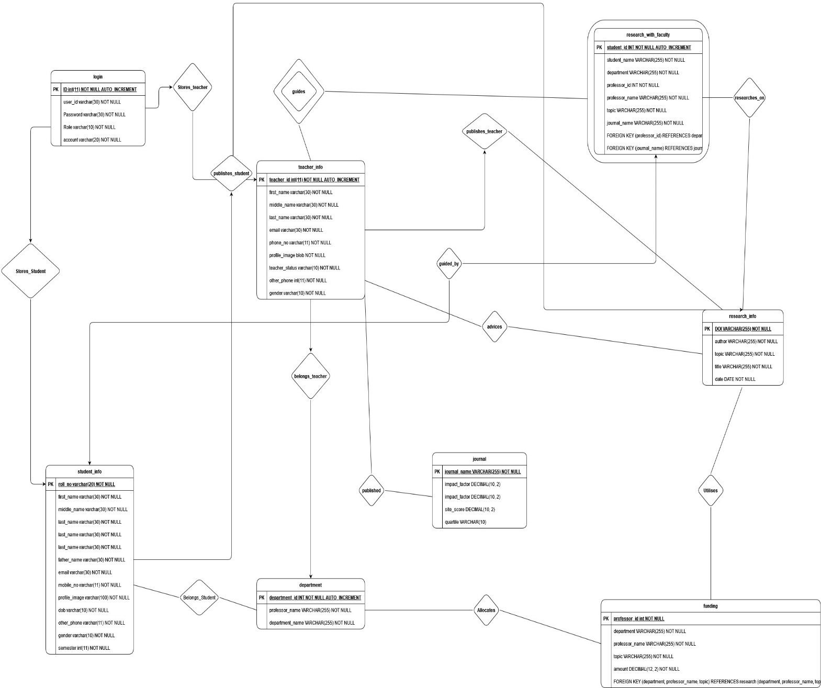

**4.3 ER DIAGRAM:**

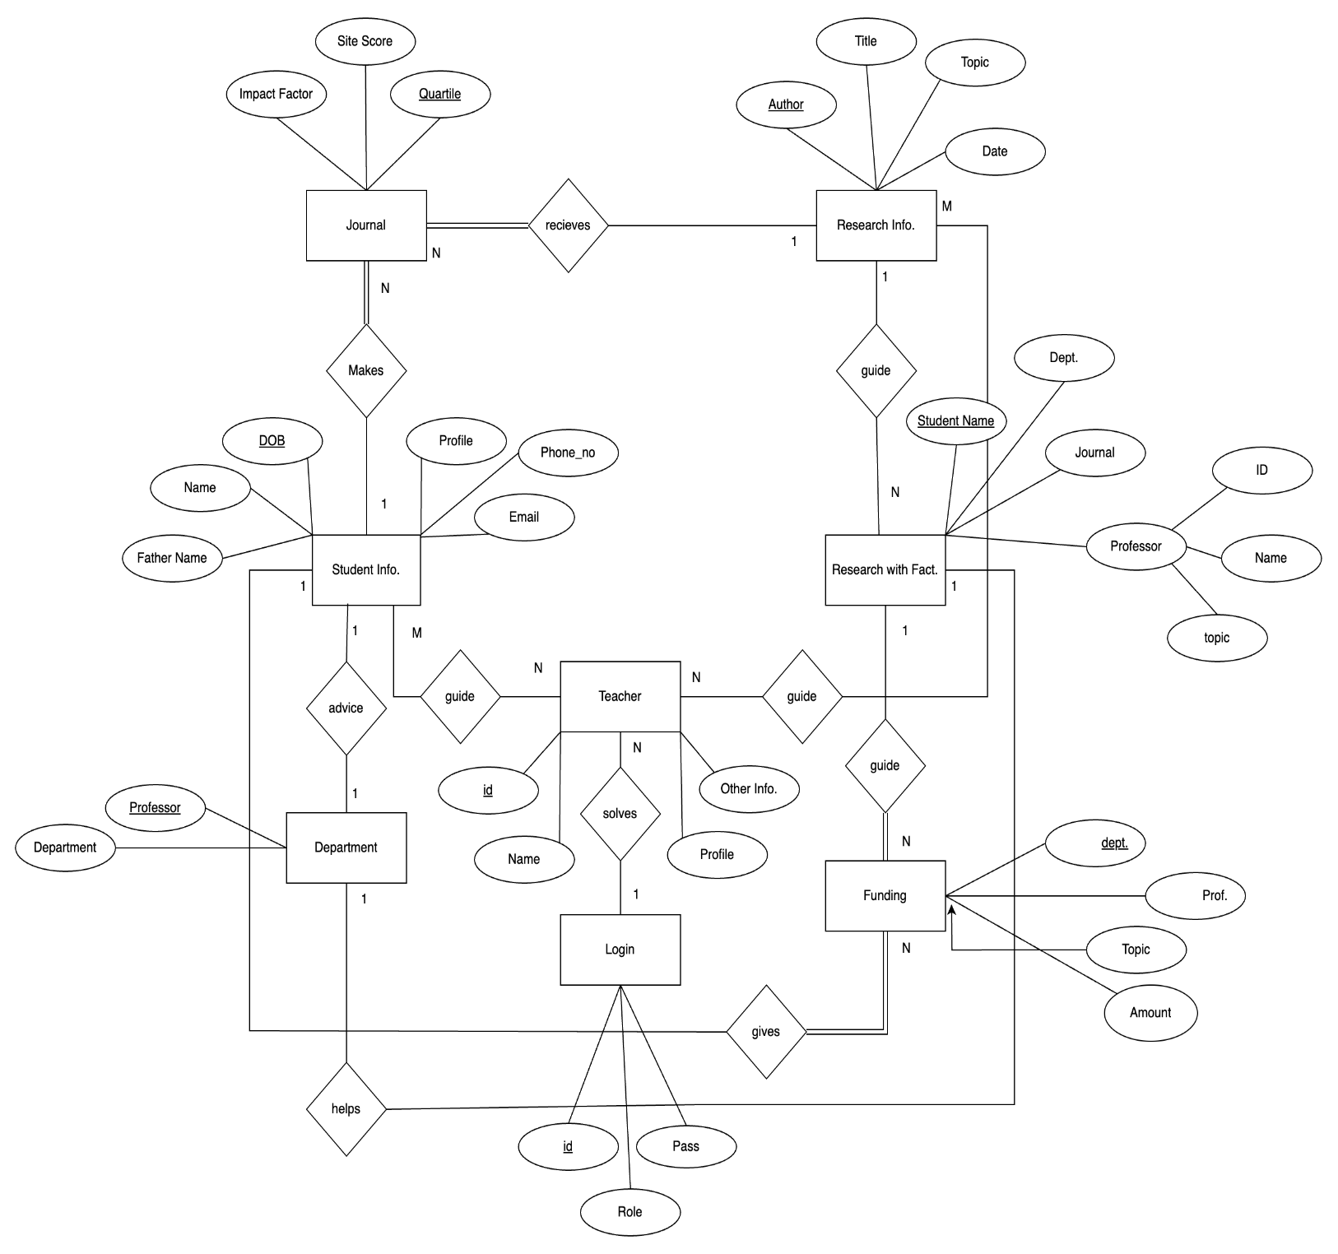

**Chapter 5**

**5.1. Requirements Gathering and Analysis**

• Stakeholder Interviews: Conduct interviews with stakeholders including teachers, students, and administrators to gather requirements.

• Analysis of Current Processes: Analyze existing research management processes to understand pain points and areas for improvement.

• User Requirement Definition: Define user requirements for the RMS including features, functionalities, and user roles.

**5.2. Database Design and Implementation**

• Database Schema Design: Design the database schema including tables, relationships, data types, and constraints.

• Database Implementation: Implement the database using SQL scripts, ensuring data integrity and security.

• Data Migration: If applicable, migrate existing research data into the new database while ensuring data accuracy.

**5.3. Frontend Design and Implementation**

• User Interface Design: Design user-friendly interfaces for teachers, students, and administrators.

• Form Creation: Create forms and screens for tasks such as research submission, review, and approval.

• Integration with Backend: Integrate the frontend with the backend database using appropriate technologies.

**5.4. System Testing and Quality Assurance**

• Functional Testing: Test each functionality of the RMS to ensure they meet user requirements.

• User Acceptance Testing (UAT): Involve stakeholders in UAT to validate system usability and functionality.

• Bug Fixing: Identify and fix any bugs or issues found during testing to ensure a stable system.

**5.5. Data Integration and Migration**

• Data Integration: Integrate research data from various sources into the RMS database.

• Data Validation: Validate and clean the integrated data to ensure accuracy and consistency.

• Migration Management: Manage the migration process to minimize disruption and data loss.

**5.6. User Training and Support**

• Training Materials: Develop user manuals and documentation for teachers, students, and administrators.

• Training Sessions: Conduct training sessions to familiarize users with the RMS functionalities.

• Technical Support: Provide ongoing technical support to users for any system-related issues.

**5.7. Maintenance and Upgrades**

• Performance Monitoring: Monitor system performance to identify areas for optimization.

• Issue Resolution: Address any issues or bugs reported by users promptly.

• Feature Enhancements: Implement new features and functionalities based on user feedback and evolving needs.

By following this comprehensive methodology, you ensure that your RMS project is well-planned, executed efficiently, and meets the expectations of all stakeholders involved.

**Chapter 6**

**Results**

**6.1 Outcomes**

The outcome of the RMS project is a comprehensive application designed to streamline research management processes within educational institutions. Key outcomes include:

* Completion of a functional RMS application tailored to the specific needs of MIT Manipal, enabling efficient management of research-related activities.
* Enhanced accessibility and convenience for faculty members, students, and administrators in submitting, tracking, and managing research projects, publications, and collaborations.
* Improved organization and storage of research data, facilitating easy retrieval and analysis for informed decision-making.
* Strengthened collaboration and communication among stakeholders, fostering a culture of innovation and academic excellence.
* Increased transparency and accountability in research funding allocation and utilization, promoting efficiency and integrity in research management practices.

**Chapter 7**

**Conclusion**

**7.1 Summary**

In conclusion, the RMS application offers a transformative solution to research management within MIT Manipal. By automating routine tasks and ensuring the security of research data, it significantly reduces manual workload and enhances operational efficiency. Its user-friendly interface requires minimal training, providing convenience for both experienced users and newcomers. The inclusion of features such as password recovery further improves usability and accessibility.

**7.2 Benefits**

The benefits of the RMS extend beyond operational efficiency. By streamlining research processes and enhancing collaboration, it contributes to the advancement of academic research and innovation. Additionally, the system's transparency and accountability in funding allocation enhance institutional integrity and trust among stakeholders. Ultimately, the RMS elevates MIT Manipal's reputation as a hub for research excellence and fosters a conducive environment for scholarly pursuits.

**7.3 Future Scope**

Looking ahead, the RMS presents opportunities for further advancement and innovation. Future iterations could explore the implementation of statistical models to visualize trends and identify research opportunities more efficiently. Additionally, integrating computer vision technologies for enhanced authentication and security measures could further bolster the system's capabilities. Furthermore, the adoption of advanced authentication mechanisms such as OTP and two-step verification could enhance data security and user authentication. Overall, the RMS holds immense potential for continued improvement and is poised to redefine research management practices in academic institutions.

**Chapter 8**

**References  
  
8.1 Source Code**

**https://github.com/shvm2/research_mamagement_system**

**8.2 Textbook**

Database System Concepts 6th Edition by Abraham Silberschatz,Henry F Korth, F Sudarshan

**8.3 Websites**

https://www.geeksforgeeks.org/

<https://www.w3schools.com/>

<https://www.tutorialspoint.com/>

<https://www.programiz.com/>

https://stackoverflow.com/

**ACM Taxonomies Used in RMS:**

**1. DATA MANAGEMENT SYSTEM**

1.1 Research Data Management: Handling and organizing research-related data such as publications, authors, and dates.

1.2 User Profile Management: Managing user information including teachers, students, and administrators.

1.3 Funding Management: Tracking and managing funding allocated to different departments for research activities. 1.4 System Analytics: Generating insights and reports based on collected data for decision-making purposes.

**2.INFORMATION STORAGE SYSTEM**

2.1 Database Management (MySQL): Utilizing MySQL for storing and retrieving research and user data efficiently. 2.2 File Storage for Research Submissions: Storing files submitted by students and teachers for research purposes. 2.3 User Authentication and Authorization: Managing user access to the system through secure authentication methods.

**3.INFORMATION SYSTEMS APPLICATION**

3.1 Research Work Registration: Allowing teachers to register their research work along with associated details.

3.2 Collaboration Tools: Facilitating collaboration among users for research projects through request and notification mechanisms.

3.3 Research Publication Management: Managing the submission and tracking of research publications.

**4.INFORMATION RETRIEVAL**

4.1 Retrieval of Research Data: Enabling users to search and retrieve research-related information from the system. 4.2 User Data Retrieval for Reporting: Providing administrators with tools to retrieve user data for generating reports.

4.3 Notification System for Users: Notifying users about important events such as submission approvals and collaboration requests.

**5. HUMAN-COMPUTER INTERACTION**

5.1 Login Portals for Admin, Teachers, and Students: Designing user-friendly login interfaces tailored to different user roles.

5.2 User Profile Interface: Creating interfaces for users to view and manage their profile information.

5.3 Research Submission Forms: Designing intuitive forms for submitting research work with necessary details.

**6.INTERACTION DESIGN**

6.1 User-Friendly Interface Design: Ensuring that the system interfaces are intuitive and easy to navigate.

6.2 Navigation and Menu Design: Organizing system menus and navigation elements for efficient user interaction. 6.3 Feedback Mechanism Implementation: Incorporating feedback mechanisms to gather user input and improve system usability.

**7.ACCESSIBILITY**

7.1 Compatibility with Various Devices and Screen Sizes: Ensuring that the system is accessible across different devices and screen sizes.

7.2 Accessibility Features for Users with Disabilities: Implementing features to accommodate users with disabilities, such as screen readers and keyboard navigation.

7.3 User Training and Documentation: Providing user documentation and training materials to help users understand and use the system effectively.

**Sustainable Development Goals (SDGs) Covered in RMS:**

**1.Good Health and Well-being:**

By facilitating research activities and collaboration, RMS contributes to the advancement of knowledge in health-related fields, ultimately leading to improvements in healthcare outcomes and well-being.

**2.Quality Education:**

RMS provides a platform for students and teachers to engage in research activities, fostering a culture of continuous learning and academic excellence.

**3.Industry, Innovation, and Infrastructure:**

Through its functionalities for managing research data, funding, and collaboration, RMS supports innovation in various industries by facilitating the development of new ideas and technologies.

**4.Sustainable Cities and Communities:**

By promoting research and innovation, RMS contributes to the development of sustainable solutions for urban challenges, such as healthcare delivery, infrastructure management, and community well-being.